Mo Fan (Leader) 115010204

Li Kengjie 115010177

Wang Junce 115010231

Ye Shuqian 115010269

Zhang Ruoqing 115010096

## Proposal of Automatic Melody Generator

### Project Description

#### Purpose

The automatic melody generator provides the amateur users with the opportunity to compose melodies.

#### Motivation

Have you ever met the situation that your failure resulted from lack of professional knowledge? It is quite difficult to acquire enough information right away in a completely unfamiliar area, such as music. Music is part of our daily life. Every one of us enjoys various music style. However, not everybody knows how to compose beautiful melodies. When people have inspirations for new melodies, they may not be able to complete the composing in detail. In order to realize the user’s dream of being a composer, we aim to develop a software to generate melody automatically or semi-automatically.

#### Functions

The software includes 2 main features: automatic music composition and semi-automatic music composition.

*Automatic music composition* composes a piece of melody without users' input. Then users can listen to the melody to ensure whether it is satisfying. If the result meets their needs, users can save the melody.

*Semi-automatic music composition* allows users to input the first musical phrase and choose the music style they want. Then the software will automatically generate the whole melody based on the style of the input musical phrase. A numbered musical notation will be generated. Then, users can choose to play the music, and mark the unsatisfactory parts, which can be regenerated by the software.

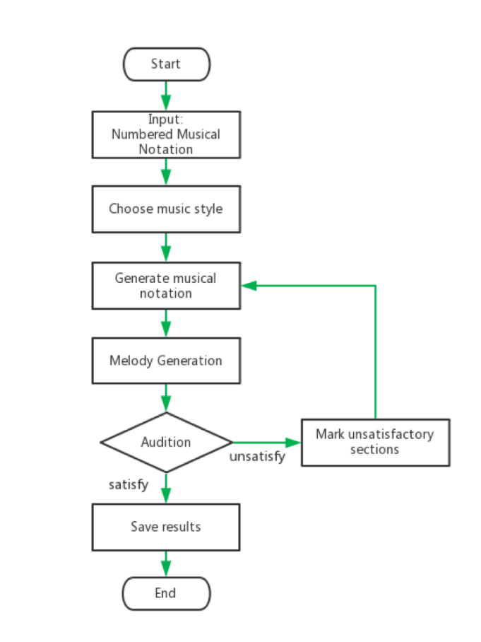

#### Algorithm

The main problem in our project is how to generate melodies automatically. The idea is to apply a combination of Markov chain and Generative Adversarial Networks (GAN). The music, or the melody as a 2-d sequence of notes recording their pitches and durations, can be trivially generated by a Markov chain. But training a Markov chain in traditional way may lose the information of consistency between musical phrases. In order to get over with it, a modern machine learning technique - GAN is applied as a measurement of how close the generated melody is similar to the existing music. The relationship and consistency between musical phrases will be considered. Besides, since the Markov chain is not as a black box as pure machine learning algorithm, with rational manually adjusting, this combination algorithm will give a better result than its components.

#### User interface

There are 3 UI demos below.

1. the start-up interface:

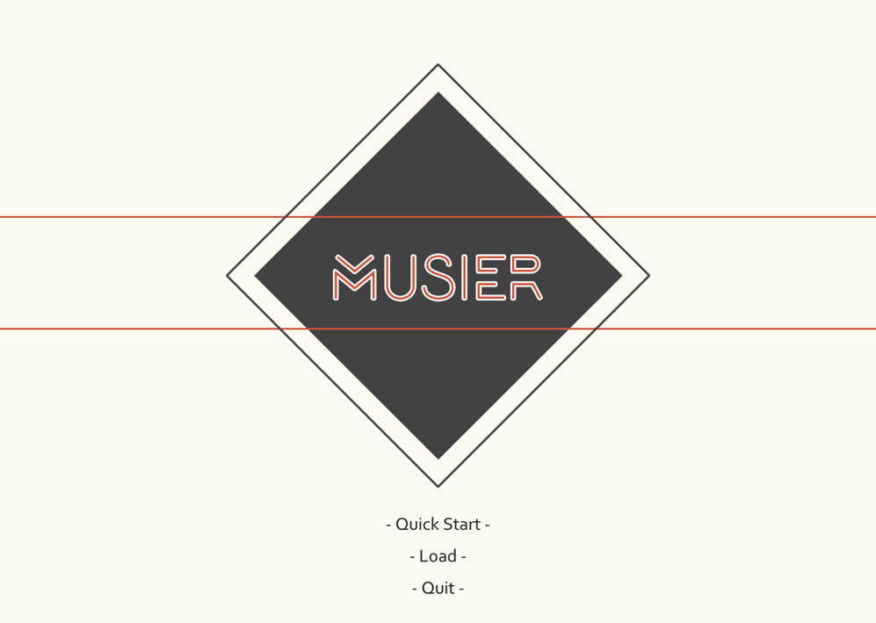

1. the interface for users to input the first musical phrase by the microphone:

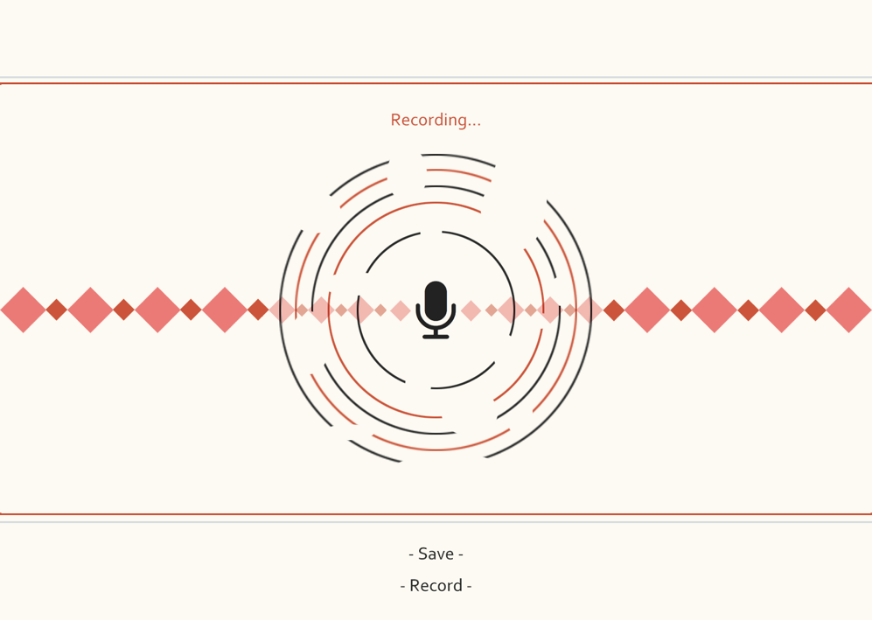

1. the interface showing numbered musical notation:

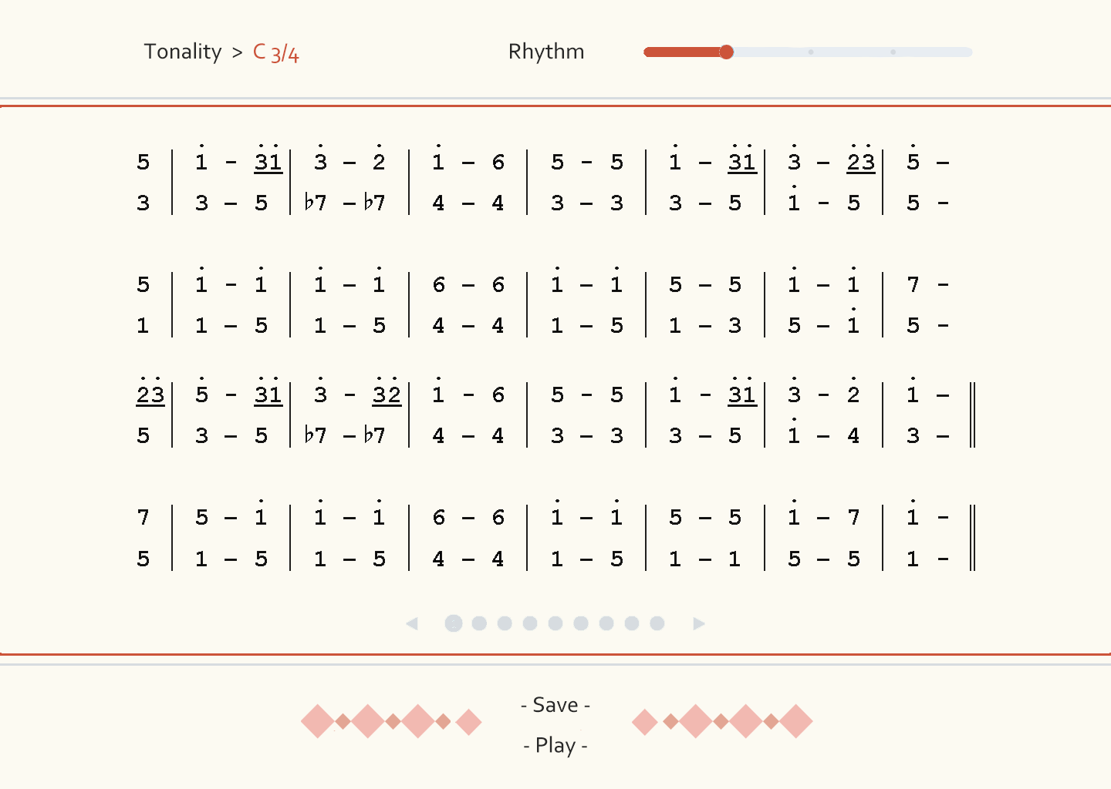

### Division of labor

Melody Composition Algorithm: Mo Fan & Wang Junce

User Interface and User Experience: Ye Shuqian & Zhang Ruoqing

Data Processing: Li Kengjie

### Timetable

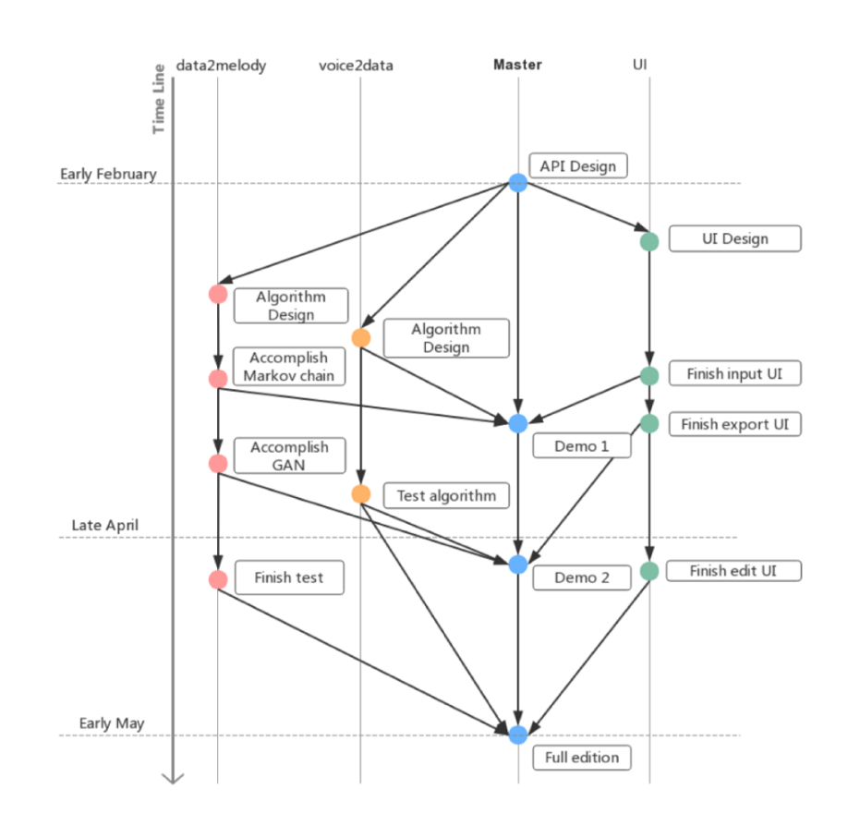

Feb.17th – API Design; UI Design

Feb.24th – Algorithm Design for transferring voice to musical data

Mar.3rd – Algorithm Design generating melody from musical data

Mar.10th – Accomplish Markov Chain; Finish UI of inputting

Mar.17th – Finish Demo 1; Finish UI of exporting

Apr.11th – Accomplish GAN

Apr.21st – Test Algorithm

Apr. 28th – Finish test; Finish Demo 2; Finish UI of editing

May.5th – Final Edition

* The timetable is flexible, which depends on the real-time schedule.